Technical Architecture Document
PPMS
Plenary Precedent Management System
Purpose:
The goal of this document is to describe the architecture necessary and sufficient for the execution of a project.

Table of contents
1. Description of architecture 3
1.1. Basic information 3
1.2. Network Architecture Schema 3
1.3. Software Architecture 4
1.4. Required Standard Runtimes 4
1.5. Non-standard server-side software list 4
1.6. Commercial software list 4
1.7. Integration 5
1.7.1. Applications integration schema 5
1.7.2. Application integration criticality 5
1.7.3. System 5
1.8. Security 6
1.8.1. Authentication mechanism 6
1.8.2. Authorisation mechanism 6
1.8.3. Specific confidentiality needs 6
2. Specific Development Tools 7
3. Annex - Document control 8
3.1. Circulation 8
3.2. Change history 8
3.3. Applicable documents 8
3.4. Reference documents 9
3.5. Glossary 9
3.6. Usage conventions 9
3.7. Procedure 'Technical Architecture' 9
3.7.1. Sending a Technical Architecture Document (DTA) 9
3.7.2. Validation of the DTA 9
3.7.3. STANDARDS support 9
3.7.4. OPERATIONS support 9
4. Other Annexes 10

Description of architecture

Basic information
This chapter describes the deliverables (applications, components, integration component) of the product in the EP's network using a synthetic schema.
Intranet | Y
DMZ | N
VLAN dedicated | N
Internet access through the EP portal | N
Other | N

Network Architecture Schema

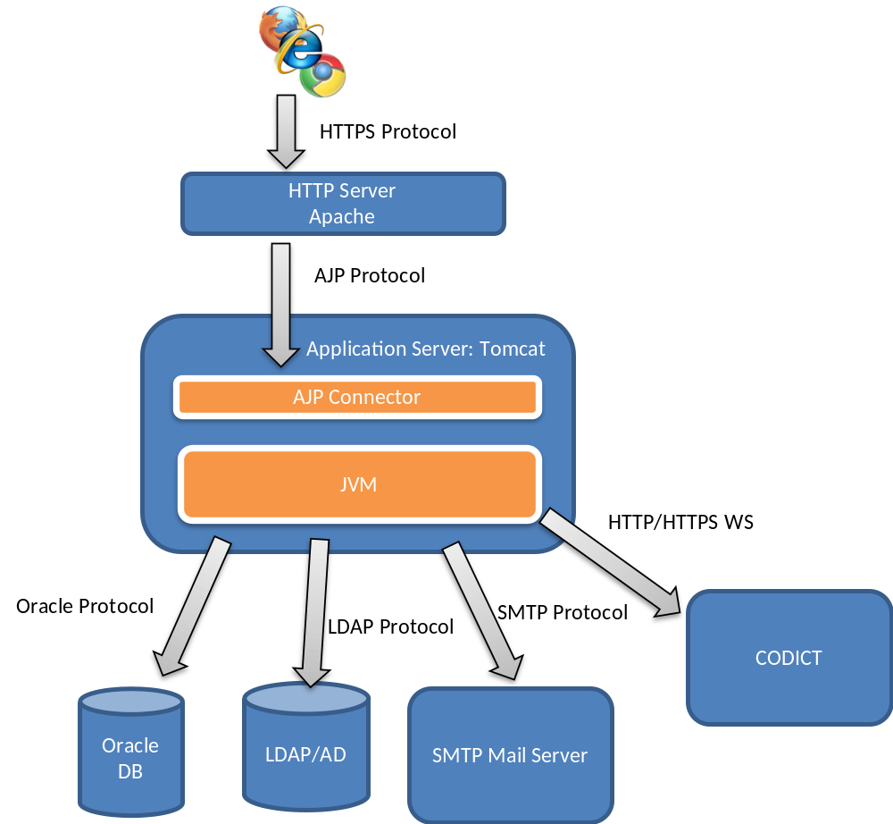
Figure 1, Network Architecture Schema
Insert a synthetic schema representing general software components in their respective network zones (application servers, applications, products, etc.), as well as their interactions and the protocols used for these interactions.

Software Architecture
This chapter describes the software architecture according to the following schema:
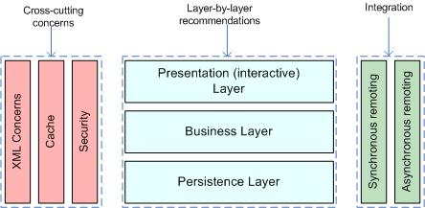

List the technologies/libraries used:
Client User interface | Bootstrap, JQuery, FontAwesome.
Server Presentation layer | JAX-RS 1.1: Java API for RESTful Web Services (JSR-311) / Spring MVC / Servlets and JSP.
Server Business layer | SPRING <= 3.2.x
Server Persistence Layer | JDBC/JPA/Hibernate Implementation.
Synchronous Remoting (WS, RMI, etc.) | WS CODICT interface
Asynchronous Remoting (JMS, etc.) | N
XML Handling | N
Cache | N
Security | JAAS Credentials
Other | N/A

Required Standard Runtimes
This chapter lists the various required server-side software (for example: Tomcat, HornetQ, etc.) and their runtime codes (allowing to map this document with multiple Runtime Hosting Request (RHR)).
List of required operational environment and associated 8 characters Code:
Existing  (Y/N) | Standard Runtime | Code  (8 char) | Environment(s)  DEV, ATE, PPO, FOR, PROD, INT
N | TOMCAT | PPMS | DEV,PPO,PROD
Please note that one separate RHR document will be needed for each new runtime.

Non-standard server-side software list
Please note that these non-standard software are most likely not to be accepted quickly, though may trigger special attention and dedicated handling. Fill in this chapter as accurately as possible.

Non-Standard Server-side software | Explanation of the need
NOT APPLICABLE

Commercial software list
Please note that these software need to purchase a license at the project level.

Commercial software | Explanation of the need
NOT APPLICABLE

Integration
This chapter describes integration of the product with other applications or services (Database, directory, etc.) and contracts and protocols used.

Applications integration schema
This section has to contain a schema describing interactions between applications. You have to precise the protocols used, and information needed to describe the exchanges (synchronous (remoting, web services), asynchronous (JMS, etc.).

No interaction with other applications.

Application integration criticality
Reference | Protocol | Synchronicity | Frequency | Business Criticality
1 | Oracle | Synchronous | hundreds of calls per minute | High
2 | LDAP | Synchronous | hundreds of calls per minute | High
3 | SMTP | Asynchronous | On demand | Low
4 | CODICT | Synchronous | On demand | Low
Optionally detail criticity:
- Oracle Protocol to access the application data.
- LDAP to validate the user authentication data.

System

List of required system services
Database | Oracle
File system (direct access, sharing, FTP, etc.) | N
Directory (Active Directory, other) | LDAP for user Authentication
Mails (sending mails from an application) | non critical
Other | N

System services schema (optional)
For clarity (and mostly if you have asked for multiple runtimes), please provide a schematic vision of the interaction between system services and applications.

Security

Authentication mechanism
LDAP based mechanism. The user credential will be validated against the corporative LDAP directory.
The communication between the browser and the Http Server should be encrypted HTTPS.

Authorisation mechanism
Database based role management system.

Specific confidentiality needs
NOT APPLICABLE

Specific Development Tools
The purpose is to mention only components which need a special or specific attention.
The STANDARDS Unit provides standard tools for the development of applications.

Mention here licence-limited tools you may need (restricted use product):
Notepad ++ | Y
Sublime Text 2.0.2 | Y
SQLDeveloper | Y
Putty | Y
Filezilla | Y
Winscp | Y

Annex - Document control

Circulation
DG or Company | Role | Name/Initials |  | RACI code
DG PRESIDENCY | MOE-Project Manager (EP) | GUY BACKAERT | GB | A
DG PRESIDENCY | MOE-Deputy Project Manager (EP) | VINCENT TURPISZ | VT | A
CGI-INTRASOFT | MOE-Senior Analyst | FORTOMAS Filippos | FF | C
CGI-INTRASOFT | MOE-Senior Developer | Angel-Ventura MENDO GOMEZ | AM | R

Change history
Version number | Status | Date | Initials | Summary of changes
1.0 | Draft | 17/06/2015 | AM | Initial version
1.1 | Draft | 17/06/2015 | AM | FF feedback on technologies
1.2 | Draft | 18/06/2015 | AM | VT,FF, feedback
1.3 | Draft | 18/06/2015 | AM | New template, architectural schema changed.
1.4 | Final | 19/06/2015 | VT,GB | Approval
1.5 | Final | 08/07/2015 | GB | Comments resulting from the review made by Standards & ICT Security Unit have been taken into account.
1.6 | Final | 08/07/2015 | GB | 1 minor correction : remove Jasper Reports
1.7 | Final | 17/09/2015 | AM | Comments from KHAIL Hassen:  DTA Validé avec les remarques suivantes :  juste remplacé LDAP Credentials par JAAS  Emacs ne fait pas partie des logiciels que nous fournissons en standard.

Applicable documents
Applicable documents are standards, specimen plans which need to be applied and whose application is verifiable.
N° | Document name | Description
[1] | Non Applicable
[2]
[3]
[4]

Reference documents
Reference documents are a help or a support but are not directly applicable (e.g. software reference manuals, sample files from outside firms, meeting papers).
N° | Document name | Description
[1] | GPS_ANALYSE_DETAILLEE_RPT_V300F(FR) | Analysis Document.
[2] | GPS_DOC_UTILISATEUR_RPT_V100F(FR) | User manual.

Glossary
Abbreviation | Description
DTA | Technical Architecture document
RHR | Runtime Hosting Request

Usage conventions
Where a chapter or section is not considered to be applicable, put "NOT APPLICABLE". Feel free to insert new sections (chapter, paragraph) as needed.
Click on the Show/Hide button in the toolbar to display/hide guidance.
Guidance displayed.

Procedure 'Technical Architecture'

Sending a Technical Architecture Document (DTA)
The DTA and/or RHR(s) documents have to be sent to the IT representatives of the DGITEC.

Validation of the DTA
As soon as the DTA is completely validated then the DTA is sent to OPERATIONS Unit to continue the treatment along with one or multiple Runtime Hosting Requests (RHR).

STANDARDS support
During the project, DGITEC can support the team project (MOA+MOE) but on request only.
DGITEC provides relevant information (standard, methods) in the Quality Assurance Manual and the appropriate documents (templates) for the project.

OPERATIONS support
OPERATIONS Unit deals with the DTA as soon as it is validated.
OPERATIONS Unit initiates a meeting with the stakeholders of the project in order to organise the technological environments necessary for the project.
For more information see OPERATIONS Website.

Other Annexes
You can change the title of the Annex and precise all information needed for the document.

Runtime: for example: Tomcat, HornetQ, etc.
Environment (DEV, ATE (Applicative Test Environment), PPO, FOR, PROD, INT, etc.)
An identifier helping to point this relation in the Application Integration Schema
Frequency of the interaction (e.g. once every night for a batch, thousands of calls per minute if directly related to end user input or interaction)
R: Responsible, A: Approval, C: Contribution, I: Informed
Naming convention: Procedure 'Program & Project naming convention'
Status: Draft, Final, Approved
Description: Note, summary, link, etc.

